## CASE 11

## Ohio Hopewell Platform Pipes

**The Platform pipe is a product of the**

**Hopewell tradition (100 BCE–200 CE),**

**which extended from the Midwest**

**to the Northeast U.S. Scuptures of**

**birds, animals and reptiles are carved on top**

**of a flat or convex base, which has been**

**drilled using copper wire traded from**

**float copper in Lake Superior. A variety**

**of materials were used, including Catlinite**

**(a red stone) and serpentine (soapstone)**

**buff, green, black).**

**US-MA-Revere Beach-Monitor Pipe-100 BCE-200 CE**

**This extremely rare platform pipe was found by me when I was six years old in 1946 when digging for clams and quahogs near Holt’s pier at the extreme southern end of Revere Beach at low tide. I had dug about 2 ½ feet below the surface where there was a deposit of broken clam shells and this pipe was among the shells. Charles C. Willoughby, Director Emeritus of the Peabody Museum, Harvard University, in his Antiquities of the New England Indians (1935, pp. 90-91).also excavated an almost identical pipe at Revere Beach in the early 1930’s and has this to say: “The platform pipe … is perhaps the most ancient New England form. …They attained their highest excellence among the Great Earthwork Builders [of Ohio]. The well-known effigy pipes of these mounds, ornamented with well executed sculptures {see examples in this cabinet] of birds, animals and reptiles, are the highest development of this type. … Platform pipes having a curved base are rare in New England. The pipe shown in … e, was found from a grave at Revere Beach, has several figures, probably flying birds, incised upon the bottom of the platform. These are doubtless totemic… .” We now know that these figures are images of shamans dressed as mythic birds performing rites to carry the deceased to the hereafter.**

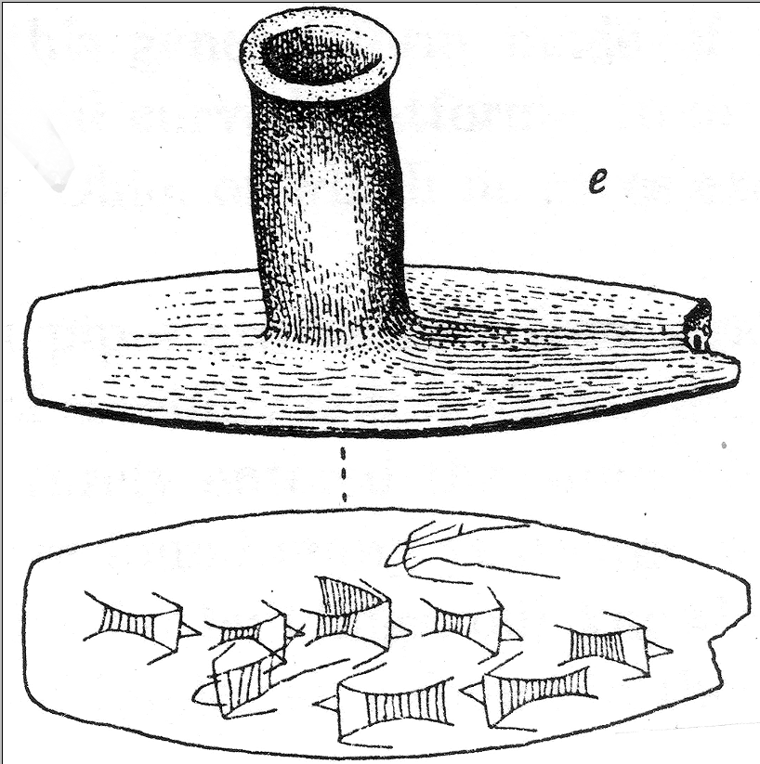

The platform pipe excavated by Charles C. Willoughby at Revere Beach, MA, in the 1930’s.

## Micronesia, Nukuoro, Breadfruit Wood *Te tino aitu* Sculpture

**Nukuoro atoll is an extremely isolated, nearly circular atoll 3.85° N, 154.9° E with a deep central lagoon and a fringing reef with forty-six small islets or *modu*. It was settled in the eighth century AD/CE, by Polynesian Samoan immigrants in two outrigger canoes under chief Wawe. First they sailed 1,000 miles from Samoa to Nukufetau in Tuvalu. Secondly, they sailed 2,000 miles nw on treacherous blue water to Nukuoro.**

**Nukuoro deities and ancestor spirits were thought to reside in animals, stones, pieces of wood or wooden figurines (*te tino aitu*), but only for the period of the first fruit rituals that took place towards the month of Mataariki, when the Pleiades are visible in the west at dusk. The rituals marked the beginning of the harvesting of two kinds of taro, breadfruit, arrowroot, banana, sugar cane, pandanus and coconuts. During the first fruit festivals the harvested fruits and food offerings were brought to this carved sculpture in which it was believed the deity resided. Dances were performed in honor of the bounty being offered and women were ceremoniously tattooed in expectation of successful childbirths.**

**Marblehead and Swampscott Spades and Hoes,**

**7,000 -5,000 years ago, the Woodland Period.**

**The smaller spades and hoes were used for clam and Quahog digging while the larger spades and hoes were used for corn agriculture that began here some 2000 years ago. Many were exposed during storms extending from the 1960’s to the 2000’s. Their exposure in areas adjacent to fresh water supplies such as Phillip’s Ponds (Swampscott) or adjacent to old corn fields such as Corn Point (Marblehead) indicates their specific types of use. There are several styles of design and hafting (attachment by lashing with rawhide or sinew) to a wooden handle. See how many types you can identify. The wooden handles and the lashing material has long since disappeared due to the acidic soils of our area.**

**Surface finds by Susan Murcott.**

**Marblehead and Swampscott Various Stone**

**implements, All 5,000 BP except two**

**Top Row: Convex-Base Spade for Clamming without hafting,**

**Large bifacial Adze (probably from the Birch Climatic Period, 18,000 BP),**

**Date based on peat cores taken by Salem State College in the 1990’s**

**An adze this large dates to the Paleolithic Period**

**Large hafted granite hoe for Corn Agriculture, 2000 BP**

**Lower Row: Net Sinker, Nutting Stone, Chunkey Game Stone (Like Curling)**

**Rough Black Basalt Hurling Stone for Warfare.**

**Surface Finds by Susan Murcott, 1980’s-2000’s.**

